
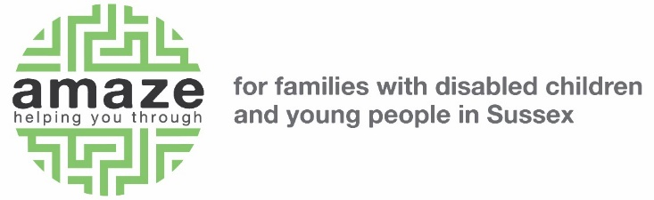

Diversity Monitoring Form

Please return this form with your application form. This can be in a sealed envelope if by post or as a separate attachment if by email.

Amaze is committed to ensuring equal access to employment, as set out in its equality policy. This includes not discriminating under the Equality Act 2010, and building an accurate picture of the make-up of the workforce in encouraging equality and diversity. Details from this form are strictly confidential, and are only used in the monitoring of our recruitment processes. None of the information on this form will be available to those people undertaking the recruitment process when considering your application.

Disability
Please note that under the Equality Act 2010 you are considered disabled if you:

- have a physical or mental impairment

- this impairment has an adverse effect which is substantial

- the effect is long term (usually lasting more than 12 months)

- there is an adverse effect on your ability to carry out day to day activities

Religion and Sexuality
These questions are from guidance based on the Equality Act 2010.

Thank you for your help in enabling us to monitor the fairness of our recruitment.

Please fill in the appropriate box in each section with an X. You can choose to leave any section blank if you wish.

AGE:

16-24 25-35 36-45 46-55
56-65 65+

GENDER:

Woman Man Non-binary

Prefer not to say Other ________________

ETHNICITY:
Asian or ◻ Indian
Asian British: ◻ Pakistani
◻ Bangladeshi
◻ Chinese
◻ Any other Asian background Please specify here: _______________

Black or ◻ Caribbean
Black British: ◻ African
◻ Any other Black background

Mixed: ◻ White and Black Caribbean
◻ White and Black African
◻ White and Asian
◻ Any other Mixed Background Please specify here: _______________

White: ◻ British
◻ Irish
◻ Traveller of Irish Heritage
◻ Gypsy/Roma
◻ Any other White Background Please specify here: _______________
Any other: ◻ Please specify here

What is the main language you use at home? _______________________

DO YOU CONSIDER YOURSELF TO HAVE A DISABILITY?

YES NO

SEXUALITY
Please select the option that best describes your sexuality.

Gay woman/Lesbian Heterosexual

Gay man Bisexual

Prefer not to say Other ________________

RELIGIOUS BELIEF

Atheism

Buddhism

Christianity

Hinduism

Jainism

Judaism

Islam

Sikhism

Other

DO YOU HAVE CARING RESPONSIBILITIES? IF YES, TICK ALL THAT APPLY

None Primary carer of a child/ren (under 18)

Primary carer of disabled child/ren Primary carer of older person

Secondary carer (another person carries out the main caring role)

Prefer not to say

